What is RdpGuard and How does it Work?
RdpGuard is a host-based intrusion prevention system (HIPS) that protects your Windows Server from brute-force attacks on various protocols and services (RDP, FTP, IMAP, POP3, SMTP, MySQL, MS-SQL, IIS Web Login, ASP.NET Web Forms, MS Exchange, RD Web Access, VoIP/SIP, etc).
It monitors the logs on your server and detects failed logon attempts. If the number of failed logon attempts from a single IP address reaches a set limit, the attacker's IP address will be blocked for a specified period of time.
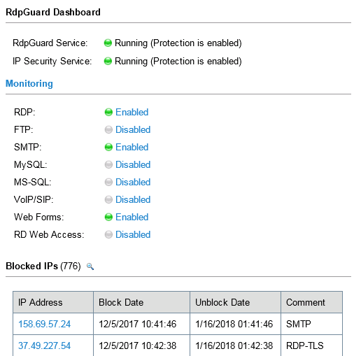
Attacker's IP addresses are blocked automatically. Click image to view other screenshots.

Why do you need it?
Many Windows Server machines are under constant attack. Network scanners and RDP brute-force tools work 24/7. Eventually they may find a password to access your server! Moreover, RDP brute-force attacks abuse server resources (CPU, RAM, Disk Space and Network Bandwidth).
Take a look at your server's Security EventLog. How many failed login attempts do you see? The log may note thousands of failed login attempts from a single IP address. This means that someone is trying to find a password to access your server.
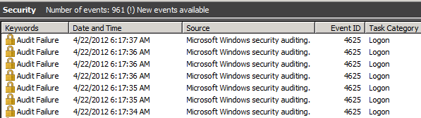
This is how an RDP brute-force attack appears in the Security EventLog.
How can you protect your server from brute-force password-guessing attacks on RDP? The answer is RdpGuard - powerful tool that allows you to protect your Remote Desktop from brute-force attacks.
RdpGuard works as a Windows Service. Your Windows Server will be protected even if nobody is logged in.
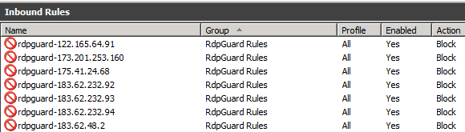
Attacker's IP address is blocked on the Firewall automatically.

Traffic Monitoring via Raw Sockets
This monitoring method works on limited set of Windows Server Editions (2008 is not supported) and may not work if there are 3-rd party firewalls or anti-viruses installed.
Advantage of this method is that it doesn't require any addional software like WinPcap to be installed.
The following dialog allows you to configure Raw Sockets monitoring method.
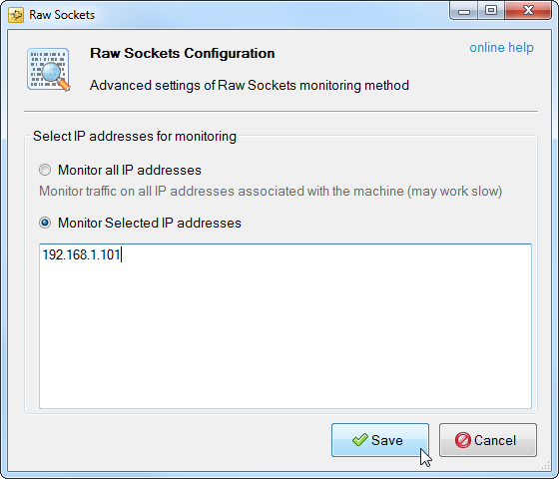
Raw Sockets Configuration

Addresses to monitor
Monitor all IP Addresses
RdpGuard listens on the protocol specific ports for an each IP address associated with the machine. This may affect server performance if there are high number of IP addresses associated with the machine.
Monitor selected IP Addresses
In order to avoid performance decrease, you may consider limiting the number of IP addresses your server software is listening on. This could be configured in server software settings or via firewall rules.
When you done with the server software configuration, you may update addresses to monitor in RdpGuard.

Traffic Monitoring via WinPcap
This monitoring method works on all Windows Server editions but requires additional software installation. You need to install WinPcap from http://winpcap.org
After installing WinPcap restart RdpGuard Service via the Tools menu.
The following dialog allows you to configure monitoring via WinPcap
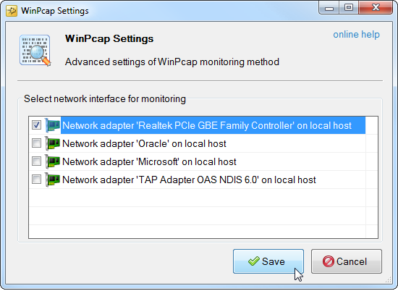
WinPcap Configuration

Network Interface for Monitoring
Select Network Interface used to listen on protocol specific ports and click Save.

RDP Brute-Force Protection Configuration
RdpGuard detects and blocks dictionary-based brute-force attacks against RDP Server. It works with all RDP Security layers: RDP Security Layer, Negotiate, SSL (TLS)

To enable and configure RDP protection
1. Start RdpGuard Dashboard and click on the link next to RDP
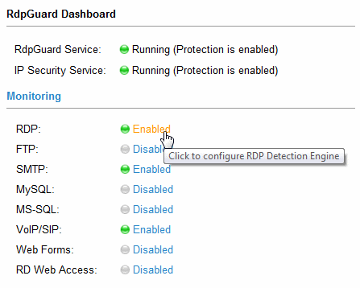
RDP Protection Link in RdpGuard Dashboard
RDP Settings dialog will open:
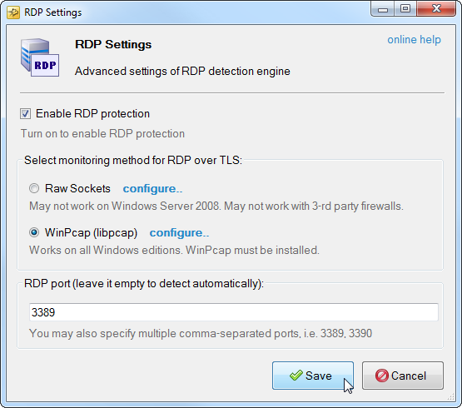
RDP Detection Engine Settings
2. Select traffic monitoring method:
As you probably know, Windows 2008 (and 2008 R2) do not write attacker's IP address to Security event log when RDP connections is made via TLS/SSL.
To work-around this issue, RdpGuard uses alternate, traffic-based approaches to detect incoming RDP connections when TLS or Negotiate security layer is selected for RDP encryption.
These approaches are:
- Raw Sockets - Does not work on Windows Server 2008 or with firewalls.
- WinPcap - Works on all Windows Editions, WinPcap must be installed.

Monitoring via Raw Sockets
This monitoring method works on Windows Server 2008 R2 only if there are no 3-rd party firewalls or anti-viruses installed. It works out of the box and doesn't require any addional software.
Addresses to monitor
When Monitoring via Raw Sockets is enabled, RdpGuard listens on RDP port for an each IP address associated with the machine. This may affect server performance if there are high number of IP addresses associated with the machine.
In order to avoid performance decrease, you may consider limiting the number of IP addresses available for RDP connection:
- Open the Windows Firewall MMC (wf.msc)
- Select the Inbound Rules section
- Get the properties of the Remote Desktop (TCP-In) rule
- On the Scope tab, choose the option to select specific IP's in the "Local IP Address" section
- Add the IP address that you want to allow RDP connections to connect to
When you done with the firewall configuration, you may update addresses to monitor in RdpGuard.

Monitoring via WinPcap
This monitoring method works on all Windows Server 2008 editions but requires additional software installation. You need to install WinPcap from http://winpcap.org
3. Specify one or multiple RDP ports to monitor (you may skip this step if you are using RDP on a single port)
4. Click Save to save changes and restart RdpGuard service.

How to Stop Brute-Force Attacks on MS-SQL Server
If you are running Microsoft SQL Server you probably aware of brute-force attacks on SA account. Almost every SQL server connected to the Internet is under constant attack.
Once a hacker has access to a SA (DBA) account, or even a normal user account, it can get full access to the file system on a server, or even to the files on the network to which it is connected.
If your SQL server accepts remote connections, System Event Log may contain thousands of entries like below:
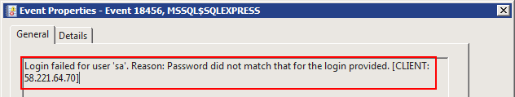
Login failed for user 'sa' error 18456.
This means that someone is trying to get access to your server. Brute-force attacks may also abuse your server resources (CPU, RAM and Bandwidth).
RdpGuard allows you to protect your MS SQL Server from brute-force attacks.
It monitors the EventLog and detects failed login attempts. If the number of failed login attempts from a single IP address reaches a set limit (three by default), the attacker's IP address will be blocked!

MS-SQL Brute-Force Protection
RdpGuard allows you to effectively stop password guessing brute-force attacks on your MS-SQL server.
It monitors system event logs (Application) for MS-SQL failed login attempts (Event ID 18456) and blocks IP addresses if the number of failed login attempts reaches a set limit.
These events are written by MS-SQL server if corresponding option is turned on in MS-SQL Management Studio.

To enable logging for failed MS-SQL login attempts
1. Start Microsoft SQL Server Management Studio
2. Right-click on your server and choose Properties
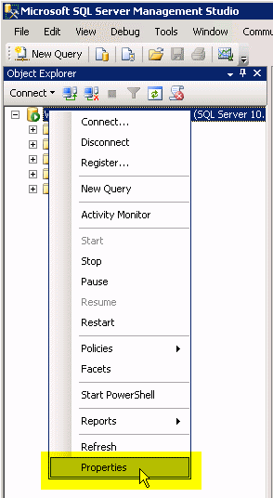
Right-click on your server and choose Properties
Server Properties dialog will open:
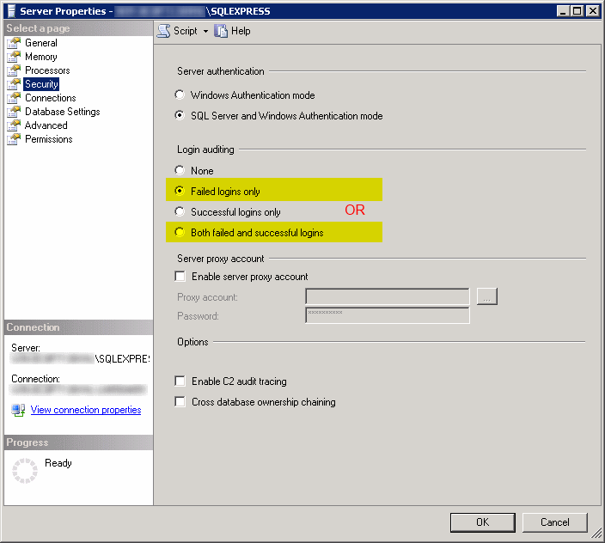
MS-SQL Server Properties dialog
3. Navigate to Security and check the Login auditing group.
4. Set Login auditing to Failed logins only or Both failed and successful logins.
5. Click OK.

To Enable MS-SQL Server Protection
1. Start RdpGuard Dashboard and click on the link next to MS-SQL
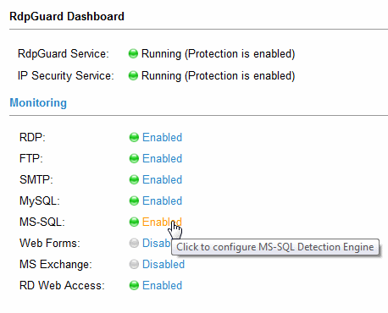
MS-SQL Protection Link in RdpGuard Dashboard
MS-SQL Settings dialog will open:
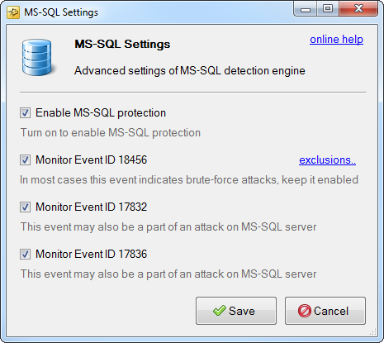
MS-SQL Protection Settings Dialog
2. Turn on Enable MS-SQL protection
3. Turn on the events you would like to monitor:
Event ID 18456 - in most cases these events inidicate brute-force attack on MS-SQL Server. It is always enabled.
Event ID 17832 - this event may also be a part of an attack on MS-SQL server. You may also enable it if you receive multiple 17832 events with the message like "The login packet used to open the connection is structurally invalid; the connection has been closed. Please contact the vendor of the client library"
Event ID 17836 - this event may also be a part of an attack on MS-SQL server. You may also enable it if you receive multiple 17836 events with the message like "Length specified in network packet payload did not match number of bytes read; the connection has been closed. Please contact the vendor of the client library"
4. Click Save

Exclusions for Event ID 18456
In some cases you may want to exclude 18456 Events from processing based on the Reason field in event details.
1. Click the Exclusions link next to the Event ID 18456 check-box
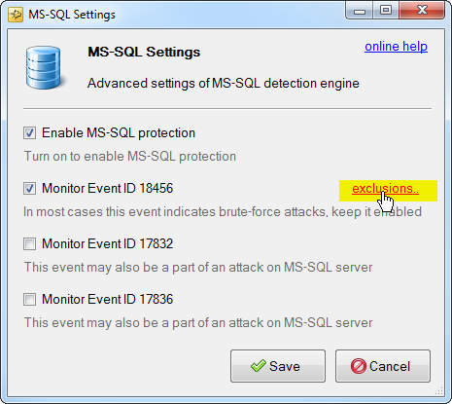
Click the Exclusions link
MS-SQL Exclusions dialog will open
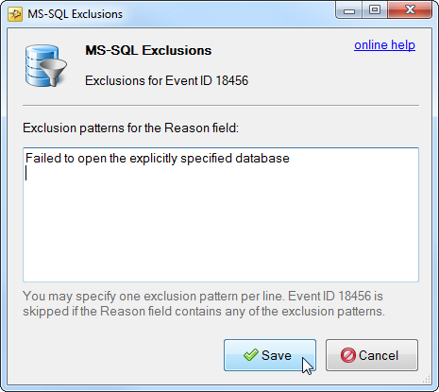
MS-SQL Exclusions dialog
2. Enter exclusion patterns for the Reason field. One exclusion pattern per line. Event ID 18456 will be skipped from processing if the Reason field contains any of the exclusion patterns.
3. Click Save

Brute-force protection for your FTP Server
If you are running FTP on your Windows Server you may observe thousands of failed login attempts in your FTP logs.
These failed login attempts are brute-force attacks on your FTP server. Hackers are trying to guess your password using special brute-force tools with dictionaries by rotating through hundreds and thousands of password variations.
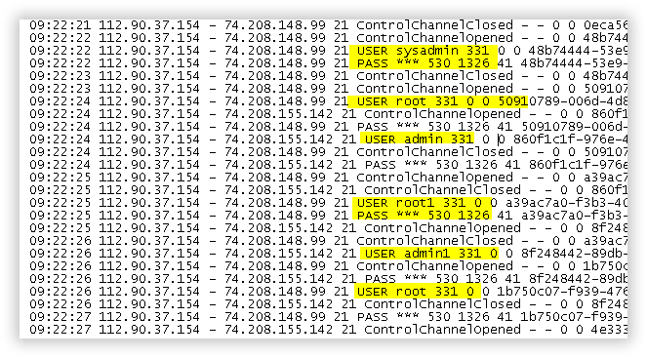
Failed FTP Logon Attempts in IIS logs
Someday they may succeed and your server might be compromised! Even if you have super strong password, brute-force attacks abuse your server resources: CPU, RAM, Bandwidth and Disk Space.
RdpGuard allows you to protect your FTP Server from brute-force attacks.
RdpGuard works with any FTP Server software and any custom ports.
It monitors one or multiple FTP ports on your server and detects failed login attempts. If the number of failed login attempts from a single IP address reaches a set limit (three by default), the attacker's IP address will be blocked.

FTP Brute-Force Protection
RdpGuard protects your FTP server from brute-force attacks. It monitors FTP port and blocks attackers IP addresses when the number of failed login attempts reaches the set limit. Check out the instructions below to learn how to enable and configure FTP brute-force protection.

To enable and configure FTP brute-force protection
1. Start RdpGuard Dashboard and click on the link next to FTP
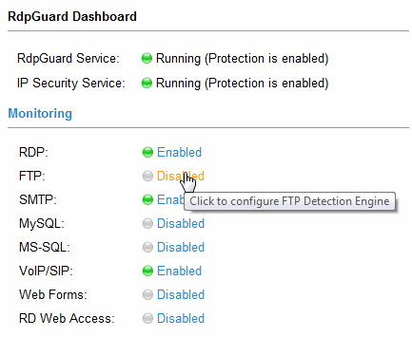
FTP Protection Link in RdpGuard Dashboard
FTP Settings dialog will open:
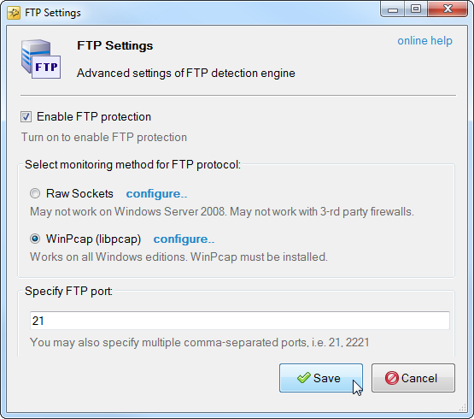
FTP Detection Engine Settings
2. Select traffic monitoring method for FTP protocol:
In new versions of RdpGuard we switched from log parsing detection to traffic based methods. This allows us to support the Protocol instead of particular software (because logs are software-specific)
The following traffic-based methods are available:
- Raw Sockets - Does not work on Windows Server 2008 or with firewalls.
- WinPcap - Works on all Windows Editions, WinPcap must be installed.
3. Specify FTP port
You may specify one or multiple comma-separated ports for FTP traffic monitoring.
4. Click Save to save changes. RdpGuard service will be restarted.

IMAP Brute-Force Protection.
Internet Message Access Protocol (IMAP) is one of the most popular protocols for email retrieval novadays. Almost every mail server supports IMAP.
Being so popular, it's not surprise that this protocol becomes the target for brute-force attacks very often - the Internet is full of tools for IMAP brute-forcing. Anyone is able to download ready-to-go tools and start abusing your server's resources.
If you are running IMAP on your server, you may notice thousands repeating entries in your logs like below:
#Software: MailEnable IMAP Server
#Version: 1.2
#Date: 03/31/18 00:00:08
#Fields: date time c-ip agent account cs-username s-ip s-port cs-method cs-uristem cs-uriquery s-computername sc-bytes cs-bytes time-taken
31-03-13 06:26:01 185.222.209.113 IMAP-IN contoso.com - 66.249.66.134 5216 AUTHENTICATE cXdlcnR5 2+NO+AUTHENTICATE+LOGIN+failed+-+Invalid+username+or+password. WIN-MN0B8V95FLF 64 0 4282
31-03-13 06:42:00 185.222.209.113 IMAP-IN contoso.com - 66.249.66.134 7156 AUTHENTICATE cXdlcnR5 2+NO+AUTHENTICATE+LOGIN+failed+-+Invalid+username+or+password. WIN-MN0B8V95FLF 64 0 4290
31-03-13 06:49:43 185.222.209.113 IMAP-IN contoso.com - 66.249.66.134 4876 AUTHENTICATE cGFzc3cw 2+NO+AUTHENTICATE+LOGIN+failed+-+Invalid+username+or+password. WIN-MN0B8V95FLF 64 0 4297
31-03-13 07:08:15 185.222.209.113 IMAP-IN contoso.com - 66.249.66.134 4876 AUTHENTICATE cGFzc3cw 2+NO+AUTHENTICATE+LOGIN+failed+-+Invalid+username+or+password. WIN-MN0B8V95FLF 64 0 4297
31-03-13 07:15:41 185.222.209.113 IMAP-IN contoso.com - 66.249.66.134 5548 AUTHENTICATE c29jY2Vy 2+NO+AUTHENTICATE+LOGIN+failed+-+Invalid+username+or+password. WIN-MN0B8V95FLF 64 0 4281
31-03-13 07:26:32 185.222.209.113 IMAP-IN contoso.com - 66.249.66.134 6580 AUTHENTICATE c29jY2Vy 2+NO+AUTHENTICATE+LOGIN+failed+-+Invalid+username+or+password. WIN-MN0B8V95FLF 64 0 4288
31-03-13 07:29:59 185.222.209.113 IMAP-IN contoso.com - 66.249.66.134 3636 AUTHENTICATE c29jY2Vy 2+NO+AUTHENTICATE+LOGIN+failed+-+Invalid+username+or+password. WIN-MN0B8V95FLF 64 0 4298
31-03-13 07:31:53 185.222.209.113 IMAP-IN contoso.com - 66.249.66.134 6828 AUTHENTICATE c29jY2Vy 2+NO+AUTHENTICATE+LOGIN+failed+-+Invalid+username+or+password. WIN-MN0B8V95FLF 64 0 4313
31-03-13 07:32:29 185.222.209.113 IMAP-IN contoso.com - 66.249.66.134 5148 AUTHENTICATE Y2F0Y2F0 2+NO+AUTHENTICATE+LOGIN+failed+-+Invalid+username+or+password. WIN-MN0B8V95FLF 64 0 4328
31-03-13 07:34:32 185.222.209.113 IMAP-IN contoso.com - 66.249.66.134 6916 AUTHENTICATE c29jY2Vy 2+NO+AUTHENTICATE+LOGIN+failed+-+Invalid+username+or+password. WIN-MN0B8V95FLF 64 0 4281
31-03-13 07:40:37 185.222.209.113 IMAP-IN contoso.com - 66.249.66.134 4160 AUTHENTICATE Y2F0Y2F0 2+NO+AUTHENTICATE+LOGIN+failed+-+Invalid+username+or+password. WIN-MN0B8V95FLF 64 0 4300
31-03-13 07:41:41 185.222.209.113 IMAP-IN contoso.com - 66.249.66.134 3568 AUTHENTICATE Y2F0Y2F0 2+NO+AUTHENTICATE+LOGIN+failed+-+Invalid+username+or+password. WIN-MN0B8V95FLF 64 0 4281
31-03-13 07:42:47 185.222.209.113 IMAP-IN contoso.com - 66.249.66.134 6320 AUTHENTICATE Y2F0Y2F0 2+NO+AUTHENTICATE+LOGIN+failed+-+Invalid+username+or+password. WIN-MN0B8V95FLF 64 0 4268
31-03-13 07:43:13 185.222.209.113 IMAP-IN contoso.com - 66.249.66.134 3568 AUTHENTICATE c29jY2Vy 2+NO+AUTHENTICATE+LOGIN+failed+-+Invalid+username+or+password. WIN-MN0B8V95FLF 64 0 4282
31-03-13 07:47:10 185.222.209.113 IMAP-IN contoso.com - 66.249.66.134 4172 AUTHENTICATE c29jY2Vy 2+NO+AUTHENTICATE+LOGIN+failed+-+Invalid+username+or+password. WIN-MN0B8V95FLF 64 0 4312
31-03-13 07:49:54 185.222.209.113 IMAP-IN contoso.com - 66.249.66.134 2288 AUTHENTICATE c29jY2Vy 2+NO+AUTHENTICATE+LOGIN+failed+-+Invalid+username+or+password. WIN-MN0B8V95FLF 64 0 4268
31-03-13 07:52:03 185.222.209.113 IMAP-IN contoso.com - 66.249.66.134 5036 AUTHENTICATE Y2F0Y2F0 2+NO+AUTHENTICATE+LOGIN+failed+-+Invalid+username+or+password. WIN-MN0B8V95FLF 64 0 4281
31-03-13 07:55:31 185.222.209.113 IMAP-IN contoso.com - 66.249.66.134 6728 AUTHENTICATE Y2F0Y2F0 2+NO+AUTHENTICATE+LOGIN+failed+-+Invalid+username+or+password. WIN-MN0B8V95FLF 64 0 4282
31-03-13 07:58:03 185.222.209.113 IMAP-IN contoso.com - 66.249.66.134 5096 AUTHENTICATE Y2F0Y2F0 2+NO+AUTHENTICATE+LOGIN+failed+-+Invalid+username+or+password. WIN-MN0B8V95FLF 64 0 4328
31-03-13 07:58:32 185.222.209.113 IMAP-IN contoso.com - 66.249.66.134 6256 AUTHENTICATE Y2F0Y2F0 2+NO+AUTHENTICATE+LOGIN+failed+-+Invalid+username+or+password. WIN-MN0B8V95FLF 64 0 4285
31-03-13 08:00:48 185.222.209.113 IMAP-IN contoso.com - 66.249.66.134 7484 AUTHENTICATE Y2F0Y2F0 2+NO+AUTHENTICATE+LOGIN+failed+-+Invalid+username+or+password. WIN-MN0B8V95FLF 64 0 4301
31-03-13 08:06:12 185.222.209.113 IMAP-IN contoso.com - 66.249.66.134 4332 AUTHENTICATE Tgd7dgw3 2+NO+AUTHENTICATE+LOGIN+failed+-+Invalid+username+or+password. WIN-MN0B8V95FLF 64 0 4280
31-03-13 08:07:37 185.222.209.113 IMAP-IN contoso.com - 66.249.66.134 8948 AUTHENTICATE YW50aG9u 2+NO+AUTHENTICATE+LOGIN+failed+-+Invalid+username+or+password. WIN-MN0B8V95FLF 64 0 4313
31-03-13 08:08:02 185.222.209.113 IMAP-IN contoso.com - 66.249.66.134 8552 AUTHENTICATE aW5mb0Bo 2+NO+AUTHENTICATE+LOGIN+failed+-+Invalid+username+or+password. WIN-MN0B8V95FLF 64 0 4297
31-03-13 08:08:22 185.222.209.113 IMAP-IN contoso.com - 66.249.66.134 8948 AUTHENTICATE aW5mb0Bp 2+NO+AUTHENTICATE+LOGIN+failed+-+Invalid+username+or+password. WIN-MN0B8V95FLF 64 0 4297
31-03-13 08:09:52 185.222.209.113 IMAP-IN contoso.com - 66.249.66.134 9008 AUTHENTICATE Y2F0Y2F0 2+NO+AUTHENTICATE+LOGIN+failed+-+Invalid+username+or+password. WIN-MN0B8V95FLF 64 0 4289
31-03-13 08:13:53 185.222.209.113 IMAP-IN contoso.com - 66.249.66.134 4944 AUTHENTICATE Y2F0Y2F0 2+NO+AUTHENTICATE+LOGIN+failed+-+Invalid+username+or+password. WIN-MN0B8V95FLF 64 0 4301
31-03-13 08:16:36 185.222.209.113 IMAP-IN contoso.com - 66.249.66.134 4988 AUTHENTICATE Y2F0Y2F0 2+NO+AUTHENTICATE+LOGIN+failed+-+Invalid+username+or+password. WIN-MN0B8V95FLF 64 0 4312
31-03-13 08:17:39 185.222.209.113 IMAP-IN contoso.com - 66.249.66.134 7344 AUTHENTICATE amVzc2ll 2+NO+AUTHENTICATE+LOGIN+failed+-+Invalid+username+or+password. WIN-MN0B8V95FLF 64 0 4297
These repeating failed login attempts are brute-force attacks on your IMAP service. They waste your server's resources- bandwidth, RAM, CPU and free disk space.
If some of your IMAP users have weak passwords, attackers may succeed and get access to the user's mailbox.
RdpGuard effectively protects your IMAP server from brute-force attacks by detecting invalid login attempts and blocking attacker's IP addresses.
RdpGuard works with any IMAP Server software.
It monitors IMAP port(s) or logs on your server and detects failed login attempts. If the number of failed login attempts from a single IP address reaches a set limit (three by default), the attacker's IP address will be blocked.

IMAP Brute-Force Protection
RdpGuard effectively protects your IMAP server from brute-force attacks.
It monitors IMAP port(s) or logs on your server and blocks attacker's IP addresses when the number of failed authentication attempts from the single IP address reaches a set limit.
Check the instructions below to learn how to enable and configure IMAP protection.

To Enable and Configure IMAP Protection
Start RdpGuard Dashboard and click on the link next to IMAP
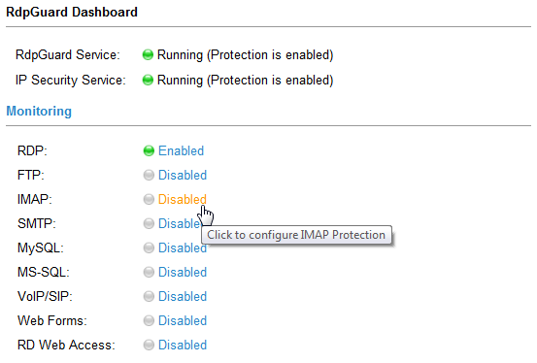
IMAP Protection Link in RdpGuard Dashboard
IMAP Settings dialog will open:
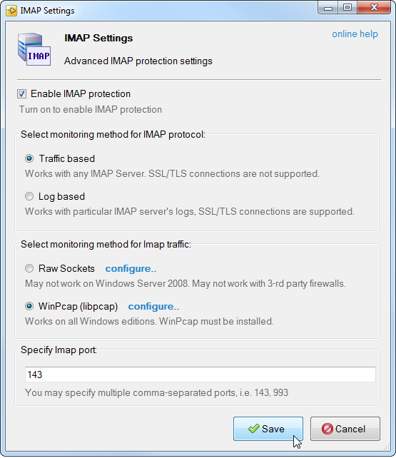
IMAP Detection Engine Settings

Monitoring method for IMAP protocol
The following monitoring methods are supported for IMAP protocol:
- Traffic based monitoring
- Log based monitoring
Traffic based monitoring works with any IMAP servers, SSL/TLS connections are not supported.
Log based monitoring works with particular IMAP server's logs. SSL/TLS connections are supported.

Traffic based monitoring
The following traffic based monitoring methods are supported
- Raw Sockets - Does not work on Windows Server 2008 or with firewalls.
- WinPcap - Works on all Windows Editions, WinPcap must be installed.
IMAP port
You may specify multiple comma-separated ports for IMAP traffic monitoring.

Log based monitoring
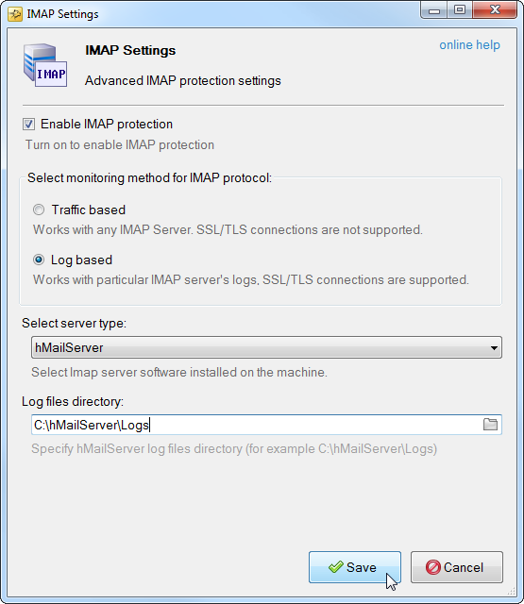
Log based IMAP Monitoring

Server type
The following IMAP servers are supported for now:
- MailEnable
- Kerio Connect
- hMailServer
- MS-Exchange
Log files directory
Specify log files directory used by selected IMAP server.

POP3 Brute-Force Protection.
The Post Office Protocol (POP) is an application-layer protocol used by e-mail clients to retrieve e-mail from a server.
The very first version of the protocol (POP1) was described in RFC 918 in 1984. One year later, in 1985, the second version of the protocol (POP2) was introduced by RFC 937. POP version 3 (POP3) is the most recent version of the protocol was originated with RFC 1081 in 1988.
During the last 10 years POP3 has been superseded by the Internet Message Access Protocol (IMAP). But, after 30 years of the introduction, POP3 is still used on many servers around the globe.
The protocol was the subject of interest from the hackers and security experts many times. In result, multiple tools for POP3 brute-forcing are freely available on the Internet.
If POP3 ports are open on your server, you may notice repeating entries in your logs like below:
"POP3D" "SENT: +OK POP3"
"POP3D" "RECEIVED: CAPA"
"POP3D" "SENT: +OK CAPA list follows[nl]USER[nl]UIDL[nl]TOP[nl]."
"POP3D" "RECEIVED: USER bob"
"POP3D" "SENT: +OK Send your password"
"POP3D" "RECEIVED: PASS ***"
"POP3D" "SENT: -ERR Invalid user name or password."
"POP3D" "RECEIVED: USER alice"
"POP3D" "SENT: +OK Send your password"
"POP3D" "RECEIVED: PASS ***"
"POP3D" "SENT: -ERR Invalid user name or password."
"POP3D" "RECEIVED: USER joe"
"POP3D" "SENT: +OK Send your password"
"POP3D" "RECEIVED: PASS ***"
"POP3D" "SENT: -ERR Invalid user name or password."
"POP3D" "SENT: +OK POP3"
"POP3D" "RECEIVED: CAPA"
"POP3D" "SENT: +OK CAPA list follows[nl]USER[nl]UIDL[nl]TOP[nl]."
"POP3D" "RECEIVED: USER office"
"POP3D" "SENT: +OK Send your password"
"POP3D" "RECEIVED: PASS ***"
"POP3D" "SENT: -ERR Invalid user name or password."
"POP3D" "RECEIVED: USER fax"
"POP3D" "SENT: +OK Send your password"
"POP3D" "RECEIVED: PASS ***"
"POP3D" "SENT: -ERR Invalid user name or password.
"POP3D" "RECEIVED: USER reception"
"POP3D" "SENT: +OK Send your password"
"POP3D" "RECEIVED: PASS ***"
"POP3D" "SENT: -ERR Invalid user name or password."

These attempts usually mean brute-force attack on your POP3 server. They waste your server's resources - bandwidth, RAM, CPU and free disk space.
If some of your POP3 users have weak passwords, attackers may succeed and get access to the user's mailbox.
RdpGuard effectively protects your POP3 server from brute-force attacks.
RdpGuard works with POP3 ports or logs on your server to detect failed login attempts. If the number of failed login attempts from a single IP address reaches a set limit, the attacker's IP address will be blocked.

POP3 Brute-Force Protection
RdpGuard protects your POP3 server from brute-force attacks.
It works with POP3 ports or logs on your server to detect and blocks attacker's IP addresses when the number of failed login attempts from the single IP address reaches a set limit.
Check the instructions below to learn how to enable and configure POP3 protection.

To Enable and Configure POP3 Protection
Start RdpGuard Dashboard and click on the link next to POP3
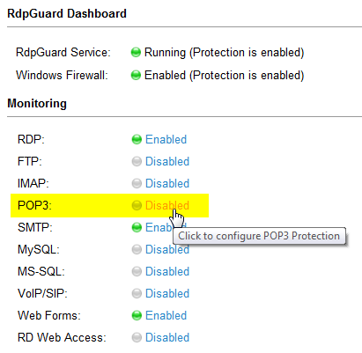
POP3 Protection Link in RdpGuard Dashboard
POP3 Settings dialog will open:
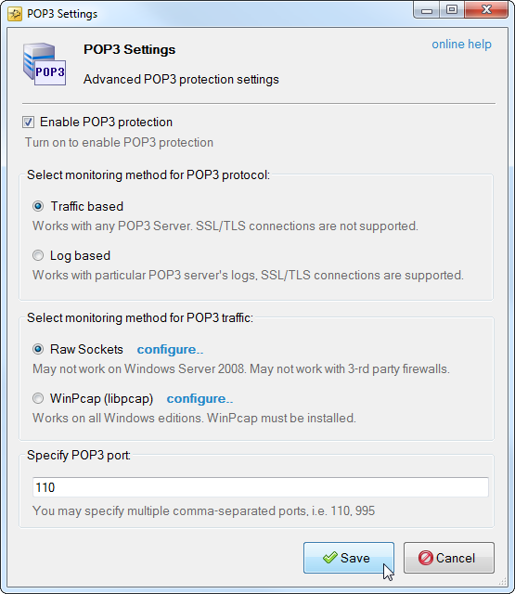
POP3 Detection Engine Settings

Monitoring method for POP3 protocol
The following monitoring methods are supported for POP3 protocol:
- Traffic based monitoring
- Log based monitoring
Traffic based monitoring works with any POP3 servers, SSL/TLS connections are not supported.
Log based monitoring works with particular POP3 server's logs. SSL/TLS connections are supported.

Traffic based monitoring
The following traffic based monitoring methods are supported
- Raw Sockets - Does not work on Windows Server 2008 or with firewalls.
- WinPcap - Works on all Windows Editions, WinPcap must be installed.
POP3 port
You may specify multiple comma-separated ports for POP3 traffic monitoring.

Log based monitoring
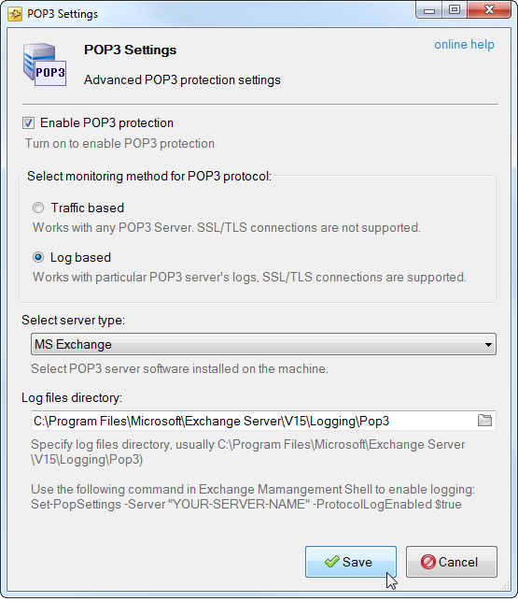
Log based POP3 Monitoring

Server type
The following POP3 servers are supported for now:
- MailEnable
- Kerio Connect
- hMailServer
- MS-Exchange
Log files directory
Specify log files directory used by selected POP3 server.

SMTP Brute-Force Protection.
If you are running SMTP on your Windows Server, you may notice that your SMTP logs contain thousands of lines like below:
"91.200.12.125" "SENT: 535 Authentication failed. Restarting authentication process."
"91.200.12.125" "RECEIVED: ***"
"91.200.12.125" "SENT: 535 Authentication failed. Restarting authentication process."
"91.200.12.125" "SENT: 220 mailserver.com ESMTP"
"91.200.12.125" "RECEIVED: EHLO User"
"91.200.12.125" "SENT: 250-mailserver.com[nl]250-SIZE 20480000[nl]250-AUTH LOGIN PLAIN[nl]250 HELP"
"91.200.12.125" "RECEIVED: AUTH LOGIN"
"91.200.12.125" "SENT: 334 VXNlcm5hbWU6"
"91.200.12.125" "RECEIVED: aW52ZW50b3J5"
"91.200.12.125" "SENT: 334 UGFzc3dvcmQ6"
"91.200.12.125" "RECEIVED: ***"
"91.200.12.125" "SENT: 535 Authentication failed."
"91.200.12.118" "SENT: 220 mailserver.com ESMTP"
"91.200.12.118" "SENT: 220 mailserver.com ESMTP"
"91.200.12.118" "RECEIVED: EHLO User"
"91.200.12.118" "SENT: 250-mailserver.com[nl]250-SIZE 20480000[nl]250-AUTH LOGIN PLAIN[nl]250 HELP"
"91.200.12.118" "RECEIVED: EHLO User"
"91.200.12.118" "SENT: 250-mailserver.com[nl]250-SIZE 20480000[nl]250-AUTH LOGIN PLAIN[nl]250 HELP"
"91.200.12.118" "RECEIVED: AUTH LOGIN"
"91.200.12.118" "SENT: 334 VXNlcm5hbWU6"
"91.200.12.118" "RECEIVED: AUTH LOGIN"
"91.200.12.118" "SENT: 334 VXNlcm5hbWU6"
"91.200.12.118" "RECEIVED: bGVnZW5k"
"91.200.12.118" "SENT: 334 UGFzc3dvcmQ6"
"91.200.12.118" "RECEIVED: bGVnZW5k"
"91.200.12.118" "SENT: 334 UGFzc3dvcmQ6"
"91.200.12.118" "RECEIVED: ***"
"91.200.12.118" "SENT: 535 Authentication failed. Restarting authentication process."
"91.200.12.118" "RECEIVED: ***"
"91.200.12.118" "SENT: 535 Authentication failed. Restarting authentication process."
These failed authentication attempts are brute-force attack on your SMTP server. We hope your SMTP passwords are strong, otherwise spammers may succeed and SPAM may go through your server causing it to get blacklisted.
Needless to say, these attacks abuse your server resources - bandwidth, CPU, memory and free disk space (SMTP logs may grow enormously).
RdpGuard allows you to protect your SMTP server from brute-force attacks.
RdpGuard works with any SMTP Server software.
It monitors SMTP port on your server and detects failed login attempts. If the number of failed login attempts from a single IP address reaches a set limit (three by default), the attacker's IP address will be blocked.

SMTP Brute-Force Protection
RdpGuard helps you protect your SMTP server from brute-force attacks. It monitors SMTP port and blocks attackers IP addresses when the number of failed authentication attempts reaches the set limit. Check out the instructions below to learn how to enable and configure SMTP brute-force protection.

To Enable and Configure SMTP Protection
Start RdpGuard Dashboard and click on the link next to SMTP
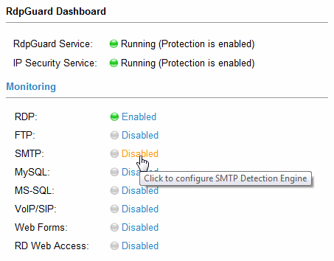
SMTP Protection Link in RdpGuard Dashboard
SMTP Settings dialog will open:
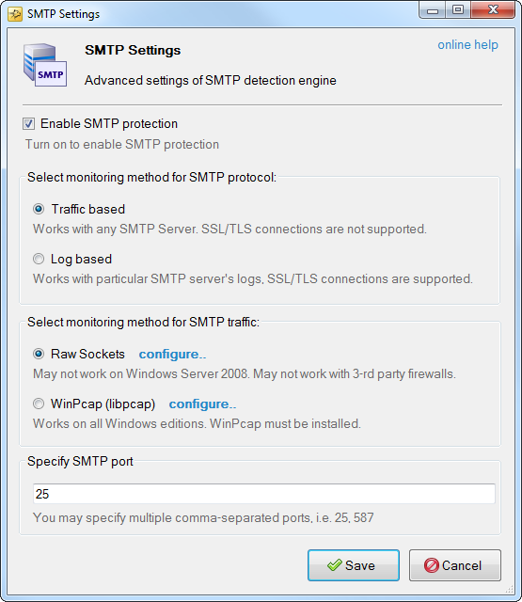
SMTP Detection Engine Settings

Monitoring method for SMTP protocol
The following monitoring methods are supported for SMTP protocol:
- Traffic based monitoring
- Log based monitoring
Traffic based monitoring works with any SMTP servers, SSL/TLS connections are not supported.
Log based monitoring works with particular SMTP server's logs. SSL/TLS connections are supported.

Traffic based monitoring
The following traffic based monitoring methods are supported
- Raw Sockets - Does not work on Windows Server 2008 or with firewalls.
- WinPcap - Works on all Windows Editions, WinPcap must be installed.
SMTP port
You may specify multiple comma-separated ports for SMTP traffic monitoring.

Log based monitoring
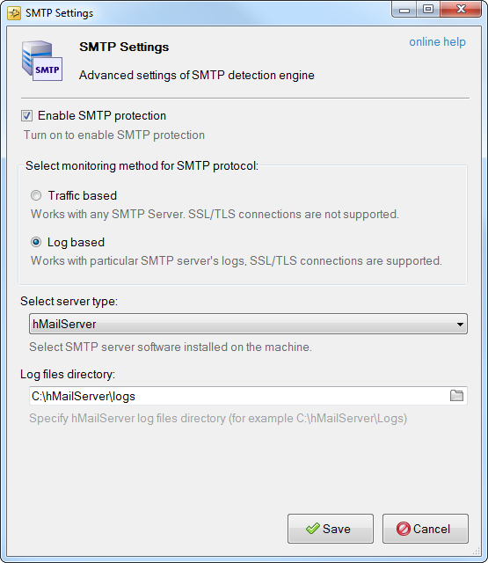
Log based SMTP Monitoring

Server type
The following SMTP servers are supported for now:
- MailEnable
- Kerio Connect
- hMailServer
- MS-Exchange
Log files directory
Specify log files directory used by selected SMTP server.

IIS Web Login Protection
- IIS Web Login Protection Overview
- How to enable IIS Web Login Protection

Protection Overview
Many of the Web Servers use built-in IIS Authentication methods to limit access to some parts of the website like admin panels and customer areas.
The most commonly used authentication methods are Basic, Digest and NTLM.
Being widely used, these authentication methods are subject to brute-force attacks on a regular basis.
Everyone is able to download freely available brute-force tools and start abusing your server and flooding the logs with thousands of failed login attempts like below:
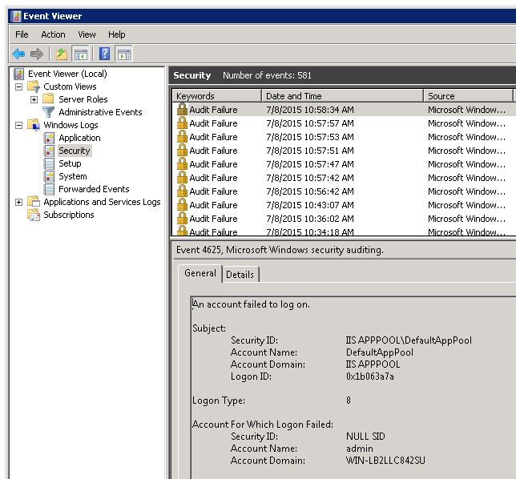
Failed IIS login attempts in the Security event log
Luckily these login attempts are logged in the Security event log and RdpGuard is able to detect and block these brute-force attempts even if they come over SSL/TLS.

To Enable IIS Web Login Protection
IIS Web Login Protection is completely covered by RDP Protection. IIS authentication methods generate the same 4625 events in Security event log as the RDP ones.
In order to enable brute-force protection for IIS authentication methods, please enable RDP protection as described in this tutorial.

MySQL Brute-Force Protection
According to Wikipedia "MySQL is the world's second most widely used relational database management system (RDBMS) and most widely used open-source RDBMS"
The flip side of this popularity is high number of various brute-force tools that are easily available on the Internet.
Your MySQL Server might be at risk if it allows remote connections. Just look at the Application event log, there should be the entries like below:
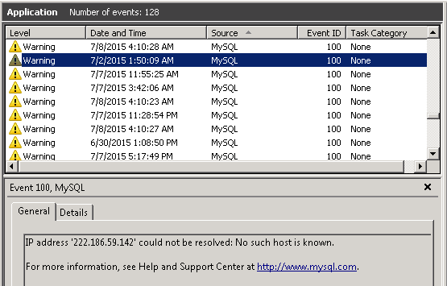
Traces of MySQL brute-force attempts in Application event log
You may be surprised, but this is only the tip of the iceberg, enable general logging for your MySQL server and wait a couple of hours.
Most likely the general log will look like below:
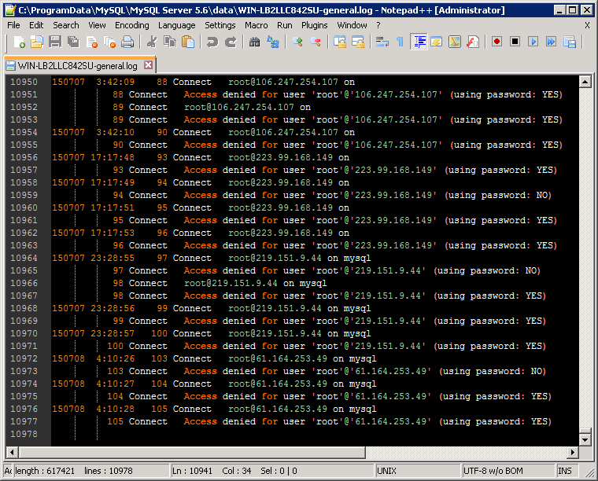
MySQL brute-force attempts in General Query Log
These failed connection attempts are dictionary based brute-force attacks which may affect the performance and security of your server.
RdpGuard is the brute-force protection software that helps you protect your MySQL Server from password guessing brute-force attacks.

MySQL General Query Log
The general query log is a general record of what MySQL Server is doing. It writes information to this log when clients connect or disconnect, including failed login attempts which often indicate brute-force attempts.
RdpGuard uses general query log to detect failed login attempts to MySQL Server.
General Query Log is disabled by default and you need to enable it in order to detect and block brute-force attacks on your MySQL server. Below you will find detailed instructions on how to enable general logging.

To enable General Logging via MySQL Workbench
Below we will describe how to enable general logging via MySQL Workbench. If you do not have MySQL Workbench installed, you can download it from here - https://mysql.com/products/workbench/
1. Start MySQL Workbench and open your instance:
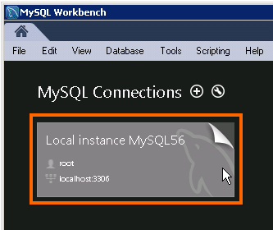
Start MySQL Workbench and open your instance
2. Open the Options File category
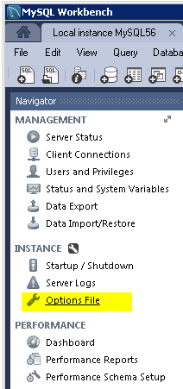
Open the Options File category
3. Open the Logging tab
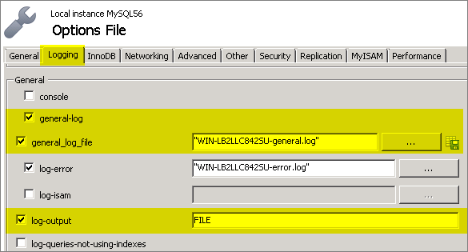
Open the logging tab
4. Check the following checkboxes:
- general-log
- general_log_file
- log-output (please also make sure it is set to FILE)
5. Click Apply to save changes.
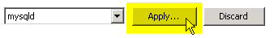
Click Apply to save changes
6. Close MySQL Workbench and restart RdpGuard Service

To enable General Logging via MySQL Config
1. Start your favorite text editor (or Notepad) and open my.ini (or my.cnf) file:
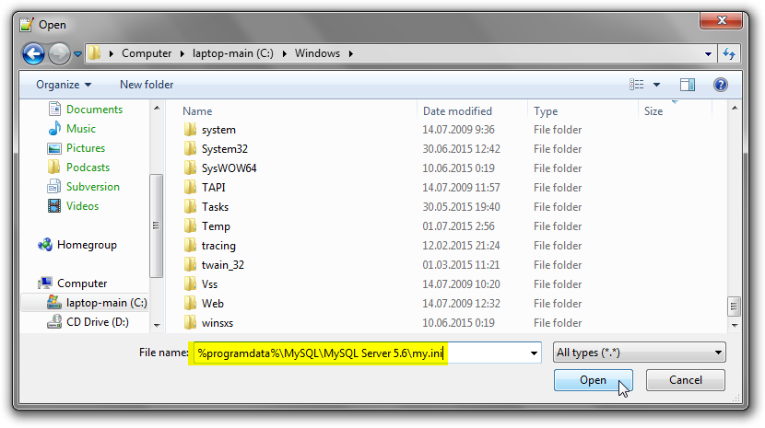
Open MySQL config file in text editor
The most common path is %PROGRAMDATA%\MySQL\MySQL Server x.x\my.ini (where x.x is MySQL Server version). You can find more details about MySQL config file location here: https://dev.mysql.com/doc/refman/5.1/en/option-files.html
2. Scroll down the config file to the following lines:
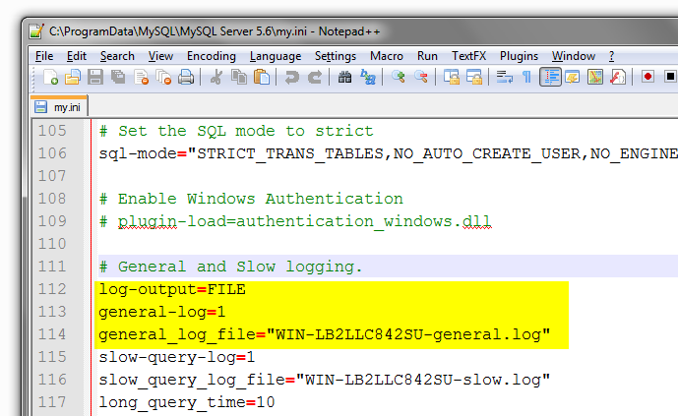
MySQL Config file in text editor
Set general logging options as below:
- log-output=FILE
- general-log=1
- general_log_file="general-log-filename.log"
3. Close the file and save changes.
4. Restart MySQL Server Service and RdpGuard Service.

MySQL Brute-Force Protection
With RdpGuard you can easily protect your MySQL server from dictionary-based brute-force attacks.
RdpGuard monitors MySQL logs and blocks attacker's IP addresses after specified number of failed login attempts. MySQL General Log is used for MySQL version 5.6 and lower and Application Event Log is used for MySQL version 5.7 and higher.
Multiple MySQL instances are supported for MySQL version 5.7 and higher.
Check out the instructions below to learn how to enable and configure brute-force protection for your MySQL server.

To enable MySQL brute-force protection
1. Start RdpGuard Dashboard and click on the link next to MySQL
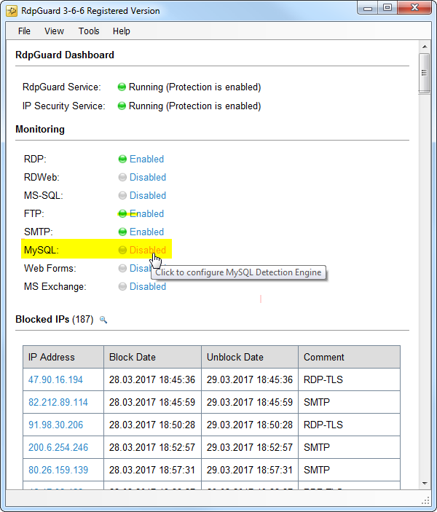
MySQL Protection Link in RdpGuard Dashboard
MySQL Settings dialog will appear:
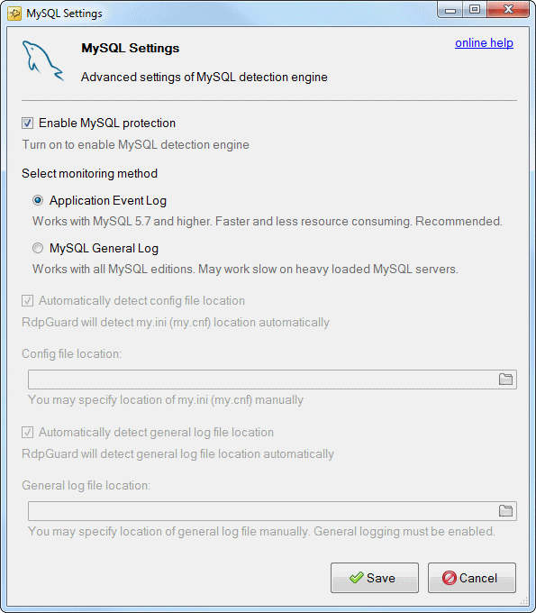
MySQL Protection Settings Dialog
2. Turn on Enable MySQL protection
3. Choose the Monitoring Method
- Application Event Log
- MySQL General Log

Monitoring via Application Event Log
Monitoring via Application Event Log is recommended for MySQL 5.7 and higher. Old MySQL versions do not write failed login information into the Application Event Log, so this monitoring method works with MySQL 5.7 and higher.
4. Click Save to save changes.

Monitoring via MySQL General Log
Monitoring via MySQL General Log works with all MySQL editions, but may work slow on heavy loaded MySQL instances.
MySQL General Logging must be enabled if you choose the MySQL General Log as a monitoring method. Please check the following instructions to learn how to enable General Logging: How to enable General Logging for MySQL Server.
5. Automatically detect config file location
In most cases RdpGuard is able to detect MySQL config file location automatically. But in some cases you may need to specify MySQL config file my.ini (or my.cnf) manually.
In such a case, disable automatic config file discovery and specify MySQL config file in corresponding text-box.
6. Automatically detect general log file location
In most cases RdpGuard is able to detect the location of general log file automatically if my.ini (or my.cnf) file is detected or specified manually. But in some cases you may also need to specify the location of general log file manually.
In such a case, disable automatic general log file discovery and specify MySQL general log file in corresponding text-box.
7. Click Save to save changes and close the dialog.
8. Enable RdpGuard Event Log via the View menu and restart RdpGuard Service via the Tools menu
9. Check out the RdpGuard Event log, if MySQL detection engine is not started, specify the location of MySQL config file and general log file manually and repeat the steps 7-8

ASP.NET Web Forms Protection
If you are running ASP.NET website, you may observe the thousands of the following events in the Application event log:
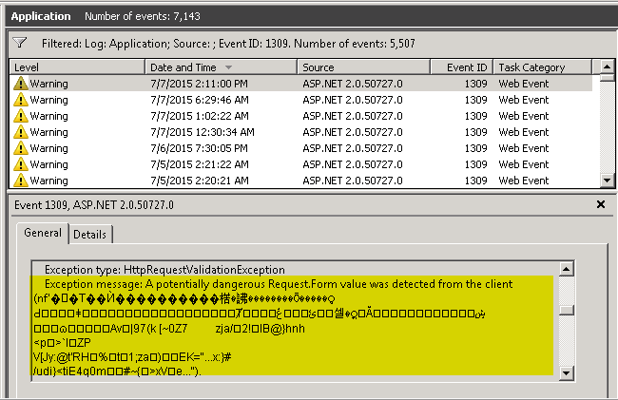
Attacks on ASP.NET Web Forms
HttpRequestValidationException: A potentially dangerous Request.Form value was detected from the client

Event code: 3003
Event message: A validation error has occurred.
Event time: 7/7/2015 2:11:00 PM
Event time (UTC): 7/7/2015 8:11:00 PM
Event ID: 921367d8836241a483053a587c3bdcd9
Event sequence: 6877
Event occurrence: 2
Event detail code: 0

Application information:
Application domain: /LM/W3SVC/1/ROOT-6-000000000000000000
Trust level: Full
Application Virtual Path: /
Application Path: C:\inetpub\wwwroot\website.com\
Machine name: xxxxxxxxxxxxx

Process information:
Process ID: 3276
Process name: w3wp.exe
Account name: IIS APPPOOL\Classic .NET AppPool

Exception information:
Exception type: HttpRequestValidationException
Exception message: A potentially dangerous Request.Form value was detected from the client (�����楛�䛍��������Ö����� [SKIPPED].

Request information:
Request URL: http://website.com/index.aspx
Request path: /index.aspx
User host address: 5.136.158.160
User:
Is authenticated: False
Authentication Type:
Thread account name: IIS APPPOOL\Classic .NET AppPool

Thread information:
Thread ID: 22
Thread account name: IIS APPPOOL\Classic .NET AppPool
Is impersonating: False
Stack trace: at System.Web.HttpRequest.ValidateString(String s, String valueName, String collectionName)
at System.Web.HttpRequest.ValidateNameValueCollection(NameValueCollection nvc, String collectionName)
at System.Web.HttpRequest.get_Form()
at System.Web.HttpRequest.get_HasForm()
at System.Web.UI.Page.GetCollectionBasedOnMethod(Boolean dontReturnNull)
at System.Web.UI.Page.DeterminePostBackMode()
at System.Web.UI.Page.ProcessRequestMain(Boolean includeStagesBeforeAsyncPoint, Boolean includeStagesAfterAsyncPoint)
at System.Web.UI.Page.ProcessRequest(Boolean includeStagesBeforeAsyncPoint, Boolean includeStagesAfterAsyncPoint)
at System.Web.UI.Page.ProcessRequest()
at System.Web.UI.Page.ProcessRequestWithNoAssert(HttpContext context)
at System.Web.UI.Page.ProcessRequest(HttpContext context)
at ASP.index_aspx.ProcessRequest(HttpContext context)
at System.Web.HttpApplication.CallHandlerExecutionStep.System.Web.HttpApplication.IExecutionStep.Execute()
at System.Web.HttpApplication.ExecuteStep(IExecutionStep step, Boolean& completedSynchronously)

Your server access logs may contain thousands of lines like below:

202.225.1.16 2015-06-28 18:58:48 POST / - - HTTP/1.1 Mozilla/4.0+(compatible;+MSIE+7.0;+Windows+NT+6.1;+WOW64;+Trident/7.0;+SLCC2;+.NET+CLR+2.0.50727;+.NET4.0C;+.NET4.0E) - 500 3245
202.225.1.16 2015-06-28 20:00:34 POST / - - HTTP/1.1 Mozilla/4.0+(compatible;+MSIE+7.0;+Windows+NT+6.1;+WOW64;+Trident/7.0;+SLCC2;+.NET+CLR+2.0.50727;+.NET4.0C;+.NET4.0E) - 200 11852
202.225.1.16 2015-06-28 20:01:19 POST / - - HTTP/1.1 Mozilla/4.0+(compatible;+MSIE+7.0;+Windows+NT+6.1;+WOW64;+Trident/7.0;+SLCC2;+.NET+CLR+2.0.50727;+.NET4.0C;+.NET4.0E) - 200 11852
202.225.1.16 2015-06-28 20:01:35 POST / - - HTTP/1.1 Mozilla/4.0+(compatible;+MSIE+7.0;+Windows+NT+6.1;+WOW64;+Trident/7.0;+SLCC2;+.NET+CLR+2.0.50727;+.NET4.0C;+.NET4.0E) - 200 11852
202.225.1.16 2015-06-28 20:32:18 POST / - - HTTP/1.1 Mozilla/4.0+(compatible;+MSIE+7.0;+Windows+NT+6.1;+WOW64;+Trident/7.0;+SLCC2;+.NET+CLR+2.0.50727;+.NET4.0C;+.NET4.0E) - 200 11852
202.225.1.16 2015-06-28 20:32:49 POST / - - HTTP/1.1 Mozilla/4.0+(compatible;+MSIE+7.0;+Windows+NT+6.1;+WOW64;+Trident/7.0;+SLCC2;+.NET+CLR+2.0.50727;+.NET4.0C;+.NET4.0E) - 200 11852
202.225.1.16 2015-06-28 21:00:35 POST / - - HTTP/1.1 Mozilla/4.0+(compatible;+MSIE+7.0;+Windows+NT+6.1;+WOW64;+Trident/7.0;+SLCC2;+.NET+CLR+2.0.50727;+.NET4.0C;+.NET4.0E) - 500 3245
202.225.1.16 2015-06-28 21:02:13 POST / - - HTTP/1.1 Mozilla/4.0+(compatible;+MSIE+7.0;+Windows+NT+6.1;+WOW64;+Trident/7.0;+SLCC2;+.NET+CLR+2.0.50727;+.NET4.0C;+.NET4.0E) - 500 3245
202.225.1.16 2015-06-28 21:02:43 POST / - - HTTP/1.1 Mozilla/4.0+(compatible;+MSIE+7.0;+Windows+NT+6.1;+WOW64;+Trident/7.0;+SLCC2;+.NET+CLR+2.0.50727;+.NET4.0C;+.NET4.0E) - 200 11852
202.225.1.16 2015-06-28 21:02:59 POST / - - HTTP/1.1 Mozilla/4.0+(compatible;+MSIE+7.0;+Windows+NT+6.1;+WOW64;+Trident/7.0;+SLCC2;+.NET+CLR+2.0.50727;+.NET4.0C;+.NET4.0E) - 200 11852
202.225.1.16 2015-06-28 21:03:38 POST / - - HTTP/1.1 Mozilla/4.0+(compatible;+MSIE+7.0;+Windows+NT+6.1;+WOW64;+Trident/7.0;+SLCC2;+.NET+CLR+2.0.50727;+.NET4.0C;+.NET4.0E) - 500 3245

This means that someone is trying to get access to your server via asp.net web forms vulnerability. Even if you have all updates and patches installed, the server may still be at risk.
Somewhat less important, but still significant, these hacking attempts abuse your server resources - CPU, RAM, Bandwidth and even the free disk space (the logs may grow enormously).
RdpGuard will help you to stop these hacking attempts and protect your Windows Web Server.

To Enable ASP.NET Web Forms Protection
1. Start RdpGuard Dashboard and click on the link next to Web Forms
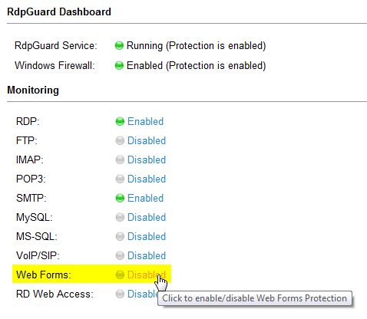
Click the 'Web Forms' link
2. RdpGuard service will be restarted.
Web Forms protection status will be changed to Enabled.
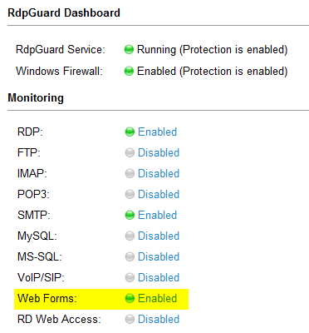
Web Forms Protection Enabled

Brute-force protection for Remote Desktop Web Access
Remote Desktop Web Access (RD Web Access), formerly Terminal Services Web Access (TS Web Access), enables users to access RemoteApp and Desktop Connection through the Start menu on a computer that is running Windows 7 or through a Web browser.
If you have RD Web Access enabled on your server, you may notice a lot of brute-force attempts that look like below in your Security Event Log:
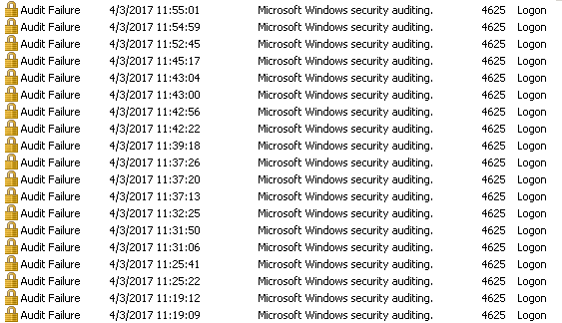
Failed logon entries in Security event log
Failed logon attempt events for RD Web Access looks like below:

An account failed to log on.

Subject:
Security ID: IIS APPPOOL\RDWeb
Account Name: RDWeb
Account Domain: IIS APPPOOL
Logon ID: 0x3091c6d6

Logon Type: 3

Account For Which Logon Failed:
Security ID: NULL SID
Account Name: Administrator
Account Domain:

Failure Information:
Failure Reason: Unknown user name or bad password.
Status: 0xc000006d
Sub Status: 0xc0000064

Process Information:
Caller Process ID: 0x143c
Caller Process Name: C:\Windows\System32\inetsrv\w3wp.exe
Your IIS logs may also contain the entries like below:

2017-03-31 11:02:26 POST /RDWeb/Pages/en-US/login.aspx ReturnUrl=default.aspx - 176.62.100.189 HTTP/1.1 Mozilla/5.0+(Windows+NT+6.1;+WOW64;+rv:52.0)+Gecko/20100101+Firefox/52.0 https://server.com/RDWeb/Pages/en-US/login.aspx?ReturnUrl=default.aspx 200 4821
2017-03-31 11:02:26 POST /RDWeb/Pages/en-US/login.aspx ReturnUrl=default.aspx - 176.62.100.189 HTTP/1.1 Mozilla/5.0+(Windows+NT+6.1;+WOW64;+rv:52.0)+Gecko/20100101+Firefox/52.0 https://server.com/RDWeb/Pages/en-US/login.aspx?ReturnUrl=default.aspx 200 4821
2017-03-31 11:02:26 POST /RDWeb/Pages/en-US/login.aspx ReturnUrl=default.aspx - 176.62.100.189 HTTP/1.1 Mozilla/5.0+(Windows+NT+6.1;+WOW64;+rv:52.0)+Gecko/20100101+Firefox/52.0 https://server.com/RDWeb/Pages/en-US/login.aspx?ReturnUrl=default.aspx 200 4821
2017-03-31 11:02:27 POST /RDWeb/Pages/en-US/login.aspx ReturnUrl=default.aspx - 176.62.100.189 HTTP/1.1 Mozilla/5.0+(Windows+NT+6.1;+WOW64;+rv:52.0)+Gecko/20100101+Firefox/52.0 https://server.com/RDWeb/Pages/en-US/login.aspx?ReturnUrl=default.aspx 200 4821
2017-03-31 11:02:27 POST /RDWeb/Pages/en-US/login.aspx ReturnUrl=default.aspx - 176.62.100.189 HTTP/1.1 Mozilla/5.0+(Windows+NT+6.1;+WOW64;+rv:52.0)+Gecko/20100101+Firefox/52.0 https://server.com/RDWeb/Pages/en-US/login.aspx?ReturnUrl=default.aspx 200 4821
2017-03-31 11:02:27 POST /RDWeb/Pages/en-US/login.aspx ReturnUrl=default.aspx - 176.62.100.189 HTTP/1.1 Mozilla/5.0+(Windows+NT+6.1;+WOW64;+rv:52.0)+Gecko/20100101+Firefox/52.0 https://server.com/RDWeb/Pages/en-US/login.aspx?ReturnUrl=default.aspx 200 4821
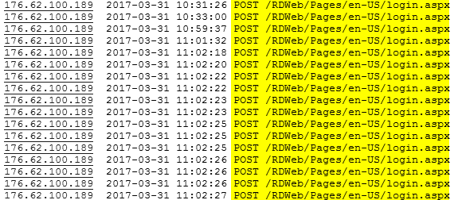
Failed logon entries for RDWeb Access in IIS logs
These log entries mean that someone is trying to find the password to your server by brute-forcing your RDWeb Access page.
RdpGuard prevents brute-force attacks on your RDWeb Access server by blocking attacker’s IP address after specified number of failed login attempts.

How to Enable and Configure RDWeb Access Protection

To Enable RDWeb Access Protection
1. Start RdpGuard Dashboard and click corresponding link next to the RDWeb Access Protection.
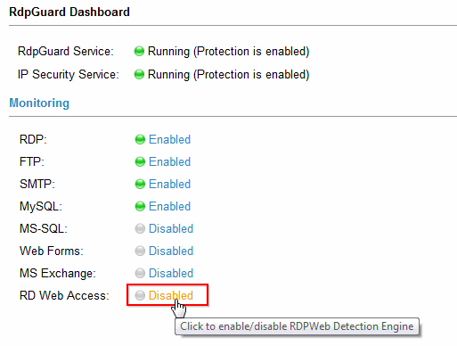
How to enable RD Web Access Protection in RdpGuard
RDWeb Protection Settings dialog will open:
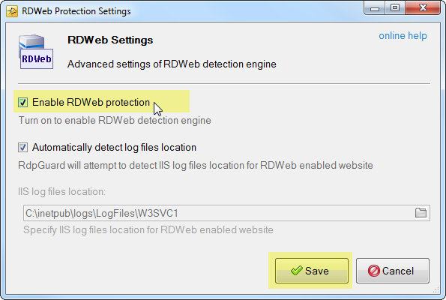
RDWeb Protection Settings dialog
2. Check Enable RDWeb Protection and click Save

RDWeb Access Protection Configuration
Automatically detect log files location - by unchecking this option you may specify IIS logs directory for RDWeb Access website manually.
In most cases RdpGuard is able to detect IIS log files location automatically. In rare cases you may need to specify it manually.

Brute-Force Protection for Session Initiation Protocol (SIP)
Just as the name says, Session Initiation Protocol (SIP) is used to establish a session between 2 or more participants, modify that session, and eventually terminate that session.
The most common use case of this protocol is to establish a session in IP telephony (VoIP/PBX Systems)
If you are running SIP enabled server software like PBX server for your office with open SIP ports, your logs may contain thousands of entries like below:
[2017/12/07 01:30:24,286] SEND,104.155.45.68:55428
SIP/2.0 401 Unauthorized
Via: SIP/2.0/TCP 10.240.0.7
From: Nessus <sip:10.240.0.7:55428>;tag=0621306b-529e-4de3-8af3-16c2add9ee9a
To: <sip:100@10.240.0.7:5060>;tag=a162044457133908
Contact: <sip:100@54.145.237.120:5060>
Call-ID: 0e03060d-8ed9-423b-8a87-a869b2c0c63f
CSeq: 361100138 REGISTER
Warning: 399 104.155.45.68 "Digest authorization required"
WWW-Authenticate: Digest realm="172.30.2.236", nonce="752341025378199770a104b155b45b68", stale=FALSE, algorithm=MD5
Server: MizuVoIPServer 8.6
Content-Length: 0

[2017/12/07 01:30:30,96] SEND,104.155.45.68:57620
SIP/2.0 401 Unauthorized
Via: SIP/2.0/TCP 10.240.0.7
From: Nessus <sip:10.240.0.7:57620>;tag=7e1c5fae-72db-4e42-9fe2-4615477df7c9
To: <sip:101@10.240.0.7:5060>;tag=a191130192120953
Contact: <sip:101@54.145.237.120:5060>
Call-ID: 2042b411-fdf0-4ef1-ae74-68ac6445cf68
CSeq: 1674088010 REGISTER
Warning: 399 104.155.45.68 "Digest authorization required"
WWW-Authenticate: Digest realm="172.30.2.236", nonce="752399215815299769a104b155b45b68", stale=FALSE, algorithm=MD5
Server: MizuVoIPServer 8.6
Content-Length: 0

[2017/12/07 01:30:36,153] SEND,104.155.45.68:59834
SIP/2.0 401 Unauthorized
Via: SIP/2.0/TCP 10.240.0.7
From: Nessus <sip:10.240.0.7:59834>;tag=1e0db670-d96b-4826-9863-aa17f45e34fc
To: <sip:102@10.240.0.7:5060>;tag=a112172719731331
Contact: <sip:102@54.145.237.120:5060>
Call-ID: ce597314-fb00-4c26-ad40-121be94cde0f
CSeq: 101627762 REGISTER
Warning: 399 104.155.45.68 "Digest authorization required"
WWW-Authenticate: Digest realm="172.30.2.236", nonce="752459741691999768a104b155b45b68", stale=FALSE, algorithm=MD5
Server: MizuVoIPServer 8.6
Content-Length: 0

These repeating REGISTER attempts usually mean brute-force attack on your IP telephony system.
Attackers are finding valid usernames first and then use dictionary-based brute-force attack to find weak passwords.
Once the password is found, the attackers can use your phone system to make expensive international phone calls.
Even if you have strong passwords, your phone system constantly works under the heavy load to serve malicious requests, consuming your CPU, Memory, Bandwidth and Disk Space (logs may grow enormously).
RdpGuard allows you to stop endless brute-force attacks on your VoIP/SIP Server.
RdpGuard works with any SIP enabled software.
It monitors one or multiple SIP ports on your server and detects failed REGISTER/INVITE attempts. If the number of failed attempts from a single IP address reaches a set limit (three by default), the attacker's IP address will be blocked.

VoIP/SIP Brute-Force Protection
RdpGuard protects your VoIP server from brute-force attacks on SIP protocol. It monitors one or multiple SIP ports and blocks attackers IP addresses when the number of failed login attempts reaches the set limit. Check out the instructions below to learn how to enable and configure brute-force protection for SIP protocol.

To enable and configure SIP brute-force protection
1. Start RdpGuard Dashboard and click on the link next to VoIP/SIP
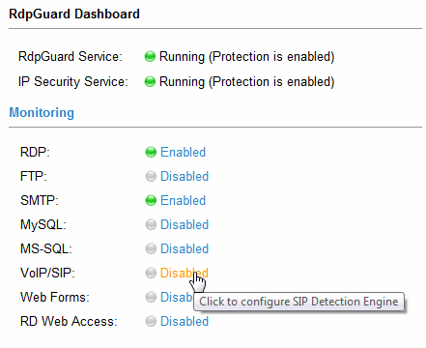
VoIP/SIP Protection Link in RdpGuard Dashboard
SIP Settings dialog will open:
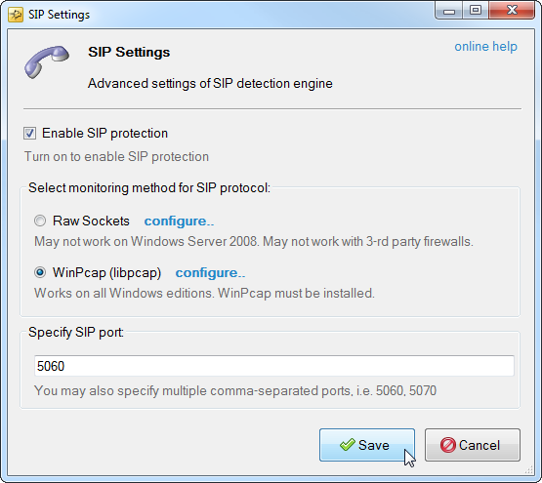
SIP Detection Engine Settings
2. Select traffic monitoring method for SIP protocol:
The following traffic-based methods are available:
- Raw Sockets - Does not work on Windows Server 2008 or with firewalls.
- WinPcap - Works on all Windows Editions, WinPcap must be installed.
3. Specify SIP port
You may specify one or multiple comma-separated ports for SIP traffic monitoring.
4. Click Save to save changes. RdpGuard service will be restarted.

